**Database and Tables for the SQL Problems**

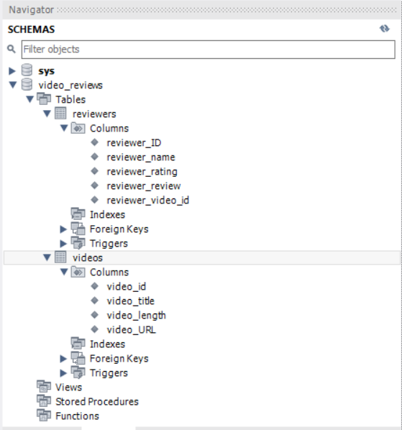

**Videos table Data:**

**select * from video_reviews.videos;**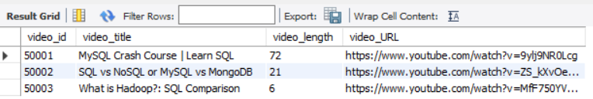

**Reviewers table Data**

**select * from video_reviews.reviewers;**

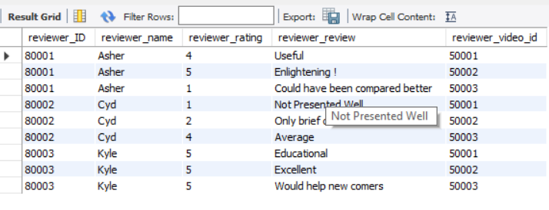

**Output of Join Query:**

**select * from video_reviews.videos vid inner join video_reviews.reviewers rev**

**on vid.video_id = rev.reviewer_video_ID**

**order by video_id asc;**

